

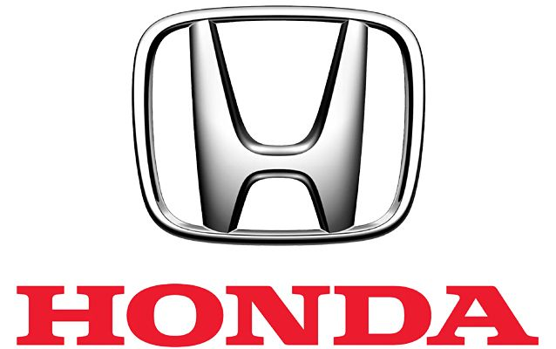

**INTRODUCTION TO WEB CONTENT MANAGEMENT AND DESIGN (IMD311): CASESTUDY: HONDA MALAYSIA**

**PREPARED BY:**

|  |  |  |
| --- | --- | --- |
| **FACULTY & PROGRAMME** | **:** | **FACULTY OF INFORMATION MANAGEMENT/**  **DIPLOMA IN INFORMATION MANAGEMENT** |
| **SEMESTER** | **:** | **MARCH 2020 – SEPTEMBER 2020** |
| **GROUP MEMBERS** | **:** | **MUHAMMAD DAILAMI BIN HAMZAH**  **(2017288808)** |
|  | **:** | **NURUL AIN IRDINA BINTI MOHD ZAWAWI**  **(2017502949)** |
|  | **:** | **NURUL IMAN BINTI ABDUL MURAD**  **(2017392143)** |
|  | **:** | **NURUL NATASYA BINTI NOR ASMARI**  **(2017500523)** |
|  |
| **GROUP** | **:** | **N5IM1105A** |

**PREPARED FOR:**

**SIR AHMAD NOOR KADER MUSTAJIR MD EUSOFF**

**ACKNOWLEDGEMENT**

Assalamualaikum,

First of all we would like to recite Alhamdulilah and grateful to Allah for giving us the strength, knowledge and His blessing in completing this group assignment and submit it on the due date that had been stated on the assignment paper.

Next, we would like to express our special thanks to our lecturer **Sir Kader** who gave to us the opportunity to do this assignment.

When we do this assignment we gain a lot of information. We would also like to expand our deepest gratitude to all those who have directly and indirectly guided us in writing this assignment. Secondly we would also like to thank our parents and friends who helped us a lot in finalizing this assignment within the limited time frame. Without helps of the particular that mentioned above, we would face many difficulties while doing this.

Finally, we would like to thank the authority of Universiti Teknologi Mara (UiTM) for providing us with a good environment and facilities to complete this assignment. Without the good environment and facilities it impossible for us to accomplish this assignment and it probably not easily done until the due date.

Thank you.

**TABLE OF CONTENT**

|  |  |
| --- | --- |
| **CONTENT** | **PAGES** |
| COVER PAGES | 1 |
| ACKNOWLDEGEMENT | 2 |
| TABLE OF CONTENT | 3 |
| LIST OF FIGURE | 4 |
| BACKGROUND OF THE WEBSITE | 5-6 |
| NATURE BUSINESS OF THE WEBSITE | 7-9 |
| UX/UI OF THE WEBSITE | 10-11 |
| COLOR SCHEME OF USE | 12-14 |
| NAVIGATION OF THE WEBSITE | 15-18 |
| CONTENT OF THE WEBSITE | 18-19 |
| APPENDICES | 20-21 |
| REFERENCES | 22 |

**LIST OF FIGURES**

|  |  |  |
| --- | --- | --- |
| **NO.FIGURE** | **CONTENT** | **PAGES** |
| 1 | The color scheme of Honda Logo. | 13 |
| 2 | The background and section column of Honda website color. | 14 |
| 3 | Navigation of mobile version. | 17 |
| 4 | Navigation of desktop version. | 17 |

**1.0 BACKGROUND OF THE WEBSITE**

The background of Honda Malaysia website has reflected its organization information and marketing tools in publishing their image on public. Honda Motor Company, Ltd. is a Japanese public multinational conglomerate corporation primarily known as a manufacturer of automobiles and motorcycles. On 15 November 2000, a partnership between Honda Motor Co. Ltd. of Japan, DRB-HICOM Berhad and Oriental Holdings Berhad resulted in the birth of Honda Malaysia Sdn Bhd, a company committed to offering the "Highest Customer Satisfaction in Malaysia". Below is the basic point that related with background of Honda Malaysia Website:

* **What is the purpose creation of Honda Malaysia Website?**

The purpose of this website creation are to deliver all important information about Honda Malaysia company in order to justify their need in obtaining sales. Web design also playing an important role on finding the potential buyer for Honda Malaysia besides encourages the visitor to do something. For instance, the visitor need to subscribe to a newsletter, to find the best vehicle image, to request a quote for price, or to download dealer-listing location.

* **Who is the potential visitors on this website?**

The potential visitor of Honda Malaysia website are Malaysia’s citizen or people that live in Malaysia or country that surrounding in Southeast Asia. This webpage also focusing on grabbing adult attention rather than children since they are still not afford to buy a car.

* **When is the time that Honda Malaysia website will receiving many access or viewer?**

Generally, this website receive many visitor from any version (web or mobile support) every day. However, this company web usually having difficulty to handle large amount of visitor in their webpage during festive seasons. This is because many promotions or deals has been upload by the admin to convince potential buyer in purchasing their product or service.

* **Why Honda Malaysia need to produce a good website?**

Everyone finds a good reason to create a website. But in general, Honda Malaysia website are being created to offer a useful service that others will use. They also strive for the best knowledge provider about their branding in virtual form which much more effective on nowadays.

* **Where is the amazing element on Honda Malaysia website?**

Great elements of images, data, video file and other element on their website hyperlink or hypermedia. Viewers will feel amazed with their core graphic since they use the suitable colour scheme that represent their company which is red and white.

* **How Honda Malaysia compiling and generate FAQ section requirement on their website?**

Topics are generate based on survey that conducted by Honda Malaysia staff. Many user will arise the same question all over again. Then the features of FAQ section on website are great to support or handling that particular situation.

**2.0 NATURE BUSINESS OF WEBSITE**

The nature business of the Honda Malaysia Sdn. Bhd. is the company's segments include Motorcycle Business, Automobile business, Financial services business, and Power product and other businesses. Honda conducts its operations in Japan and around the world, including North America, Europe and Asia. Honda markets its products through a sales network of independent local dealers. The company produces sedans, hatchbacks, electric and sport utility vehicles as well as offers maintenance, parts and merchandise. Honda has always been passionate in innovating technology and challenging boundaries of mobility advancements. It is their continuous commitment in providing joy of mobility for communities all over the world with our innovations in safety, environment and advanced mobility. Below is the basic point that related with nature business of Honda Malaysia Website:

* **What is the importance of Honda website to an organization and visitor for business?**

Most visitor are looking online for information that will help them make smarter purchasing decisions. As the backbone of their online presence, every type of communication piece of content or advertisement that Honda website put online will drive the consumer back to their website. The Honda business websites build credibility with contact. It’s where potential customers, clients and associates can find and contact the Honda staff. A automobile company such as Honda Malaysia website provide with its domain makes an e-mail more credible and trustworthy rather than generic google addresses. For example, Honda website give businesses their own unique online identity.

* **Why Honda use the website as the promotion channels to promote their**

**business?**

Honda use the website as the promotions channels to create awareness and persuade the customers to buy the product and services on offer. Without proper promotion, Honda business would remain stagnant it would be difficult to generate profit due to low visibility in the market. In advertising in particular, illustrations are designed to communicate a concept and covey a message to the target audience. The purpose of Honda website as the marketing channels is to attract and catch the viewer’s eye. The Honda Malaysia website help Honda company to increase their sales opportunities and increase availability to makes sales.

* **When visitor should engage with the customer services or dealer at the contact section?**

By selling the products and services online, Honda website provide visitor with the information they need to make an informed purchasing decision. Effectively, the content that’s on Honda website serves as an additional sales person ,helping visitor get the information they need and convincing them of the benefits of the Honda product and services. For example, the customer can access at the dealer section where customer can search where they want to deal at the nearest place. It is important to provide the dealer section where customer can have the fastest services.

* **Who can involve or purchase with the Honda product through their website?**

Everyone can access and purchase the Honda product through their website. The Honda website Malaysia is the public site which anyone can access without limitless. The Honda website provide visitor with the structured content which enables visitor to discover information more easily. Discovery is an important part of the content consumption experience. For example, the Honda website content is structured and this can provide taxonomy-based search navigation for the visitor and allow them to dig deeper into related media.

* **Where user can get the latest update about the Honda product on their website?**

The user can access through the promotion sections which is enable customer to access to the new product such as new Honda mobile. This section give the customer a huge variety of eye-catching ways to add promotions to the sites. It is where the potential buyer can go through their website to purchase or have a survey on any promotions that Honda makes.

* **How effective the website footer in include the few links to relevant resources regarding about their business?**

The customer can access at the contact services where the facebook and youtube icon can be seen at the website footer. A website footer is found at the bottom of the Honda site pages. It typically includes important information such as copyright notice, a disclaimer or a few links to relevant resources such as Honda Facebook and Youtube. Links are very important especially when it comes to key words or a phrase that the visitor is looking for. It also provides an opportunity to reach new visitors who are just browsing on. Overall links can be very useful to the organization such Honda Malaysia website.

**2.0 UI/UX OF WEBSITES**

For the website creation, the UX and also UI take most important role as they are working together as a unison in order to fill the same purpose to the end-users. Some of the people will said that the “poor UI” of a website or how “great the UX” is for a certain website or product. People might hear these words from some profession from the tech industry. Well, for your information, UX and UI is not some code or slang that’s make certain conversation look more cooler or such. It is a short-form of the certain words that shall be explain below.

* **What exactly is UI and UX ?**

UX are refers to the term “User Experience” while UI are stands for “ User Interface”. Now you know what is UX and UI are. So, both elements are crucial and important to the product and also for the end-users. User Experience applies to anything that can be experience by the users be it a website or something else. To achieve this, the interface must be stunning and easy to manoeuvre on the website.

* **Who are the potential users for Honda Malaysia in UX and UI?**

Generally, for those users that seems interesting in exploring in Honda Malaysia website for specific purpose such as car models, dealers, service and maintenance for the Honda owners in Malaysia. When talking about cars, users that experience and feels the Honda Malaysia website is variable from young to old people but it serves one major purpose which is to promote their product to the users.

* **When is the UX and UI for Honda Malaysia kicks into the users ?**

Just like the VTEC kicks in, people will experience and see the website design when a new model arrived in Malaysia as they want to know more about the detail of the car such as Honda Civic Type-R. All of the necessary information has been put in the Honda Malaysia website. In the automotive industry, people keep coming and go as a new model begin to show their face so in general, users will visit the Honda Malaysia website and begin experiencing the UX and UI consistently.

* **Why Honda Malaysia need to produce a perfect UX and UI for their website ?**

As we said earlier, User Experience and User Interface is the key that can grab users attention and from the website itself, users can evaluate how bad or good of Honda Malaysia website and as usual, first impression is always take priority for people. One more is to keep their good image for the public. The name Honda itself carry a big name for the company and they have to make a good publicity which is the good website for their own good.

* **Where is the amazing element on Honda Malaysia website?**

If you dive into the Honda Malaysia website, you will see stunning graphic, organized charts, and images also some of others element such as hyperlink and suitable color scheme which is red and white that represent their logo. The website is simple and friendly users yet stunning and highly talented ux and ui designer created Honda Malaysia website. Its all depend on the UX and Ui on the website, how the website been designed to the users and how the users experience the website themselves.

* **How Honda Malaysia achieve high quality website ?**

As the name Honda itself is high quality, it has been mention that the UX and UI elements is very crucial for the website. Honda Malaysia doesn’t make repetitive design in their website, but various and beautiful design has been created for every topic. Variable design and interesting content makes the website looks more compromising.

**4.0 COLOR SCHEME OF WEBSITE**

A color scheme consists of a combination of colors used in a range of design disciplines, from fine art to interior design to graphic design. Each color scheme consists of one or more of the twelve colors present on the color wheel. Different color combinations evoke different moods or tones by using color theory and color psychology. The website company can use colors to stir their visitors emotions or respond to a call-to-action on their website. Fact, the color scheme is one of the most important elements this is because, when use correctly, color can reflect the niche and even the overall business marketing strategy.

* **Why Honda use the best color scheme in their website?**

The best color scheme is important to use in Honda website for information intensive and ecommerce websites is a white or light background, with bold dominant & accent colors. The bold dominant and accent colors give the website personality and focal points, while the plain background color keeps the visitor’s focus on the Honda content or product. Marketing colors like red can capture attention. The red color meaning is associated with excitement, passion, energy and action of Honda website.

* **What is the Honda website background color and their logo?**

The Honda website background color is white and light grey. The Honda Logo Color Palette with Hex & RGB Codes palette has only one color which is Boston University Red (#CC0000).This color combination was created by user Rocco. The logo of the world-famous automobile manufacturer has the company name, Honda, in red and the tag line in black. The Hex, RGB and CMYK codes are in the table below. When people see the color red, it triggers emotional responses like excitement, boldness, love and passion.

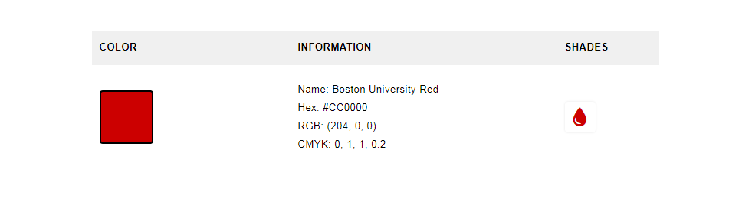

**Figure 1**: The color scheme of Honda Logo.

* **Where color scheme in Honda website can be found in their website?**

The color can automatically found in the first main page of the Honda website. The first color can be see is white and at the section column the color is red. This allows the content to be the focal point while working harmoniously with their dominant and the accent colors makes the visitor feel good while browsing to the Honda website. For example, when visitor click to another section, the color scheme in Honda website also change. For example, if the visitor click on the Contact us section, it directly

* **When in doubt, why is important to use white or very light gray as the background color as the Honda website?**

The important to use the white color and very light gray color in the Honda website is this enable the Honda website content will always shine through because by choosing a neutral or white background, the content will naturally become more attention grabbing. For example, the navigation color is red and the background content in section column is white.

* **Who can customize and design the background of color scheme in the Honda website?**

The IT staff and web developer of Honda staff are only in charged and assigned to customize and design the background of color scheme in Honda website to ensure the website are attractive and fully responsive to the visitor. They are responsible for designing, coding and modifying websites from layout to function and according to a client’s specification. Strive to create visually appealing sites that feature in Honda website is user-friendly design and clear navigation.

* **How color scheme of Honda website can attract the customer to visit their website?**

Every color holds a universal meaning that causes us to react in a specific way. These reactions have been well-documented, which is why Honda website can use colors to their advantages by directing the viewer to respond. The combination of red, grey, and white color in Honda website can makes the visitor feel excited, engaged and even inspired by the visual design of Honda website, which is the key to turning visitors into customers. For example, the background color of Honda website is red which is the color of power. It gets people’s attention and it hold it, which is why it’s the most popular color for marketing.

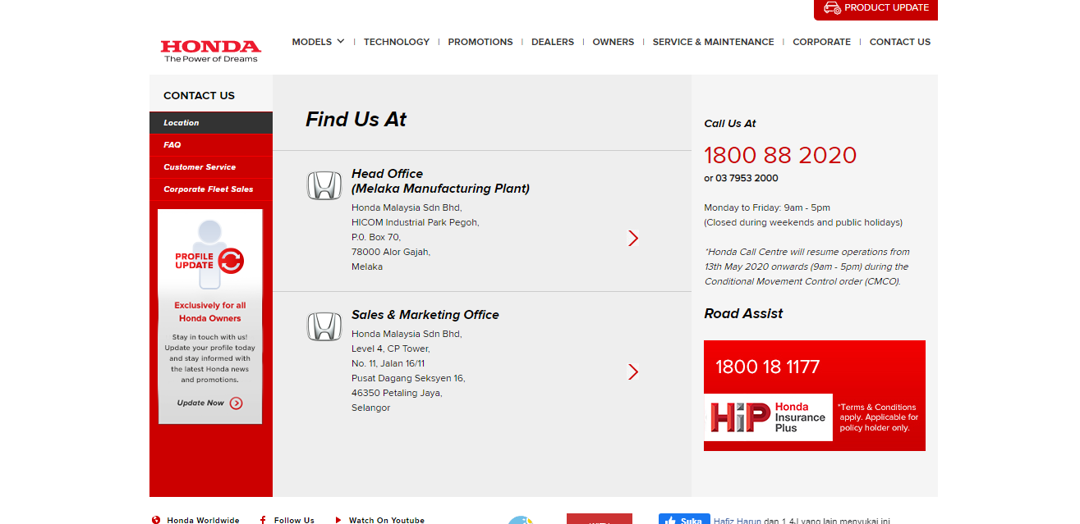

**Figure 2**: The background and section column of Honda website color.

**5.0 NAVIGATION OF THE WEBSITE**

* **What is the differences between mobile version and desktop version of navigation on Honda websites?**

On Honda websites, they provides two version of navigation for the visitors to access their websites which is mobile version and desktop version. With this way, visitors can easily access the websites anywhere and anytime by using any devices that they have. Both of the version have a different type of navigation design and format. On the mobile version, they more focus on visitors that want to access and search the important information quickly. The navigation design on the mobile version is they are using the sidebar navigation which is includes a lot of subject related to the Honda Company for the visitors easy to access the information. They also implement the minimalist design on the mobile version in order to make the websites no too crowded with a lot of useless information. Next, on the desktop version, this websites using drop down navigation bar. This navigation design are more suitable for the desktop version because it is can provide a lot of information and also visitors can easily find the information by just going through at the drop down navigation bar to find the information that they want. Both of the version of navigation on the Honda websites provide the same information and the only differences of the navigation on this websites is the design that they implemented on each version.

* **Who can access and navigate the Honda websites?**

As the purpose of the Honda websites is to deliver all the important information about Honda company in Malaysia, the people that can access and navigate the websites is everyone that are interested on the company. The content on this websites also are more focused on their customer that want to find information such as the promotion that the company, the privileges of the Honda owners, services and maintenance that the company provides and many more information that are more focused on the Honda owners.

* **Where can visitors find the navigation bar on the Honda websites?**

Visitors can find the navigation bar on the Honda Websites as soon as they opened the websites. On the mobile version, the navigation bar located at the left side of the websites meanwhile, on the desktop version, the navigation are located at the upper side on the websites. This websites does not provides the search bar, this is because all the information can be find on the navigation bar on the websites.

* **When the visitors should use the navigation bar?**

The function of the navigation bar is to provides information that are related to the company such as the location of the stores, the contact information and any others important information that the visitors needed. Visitors of this websites can access the navigation anytime that they want. The best time to access this websites and use the navigation bar is usually on the weekdays on the office hour. This is because, visitors can ask the question on the staff at the Honda Company and they will answers as soon as possible. They are also provides a navigation for their Honda customers to update their profile easily by doing at the websites only.

* **Why does the Honda website need the navigation?**

Navigational design is very important for each company to established their websites for their customers. The goal of the navigation is to encourage, promote, and enable user behaviors to accomplish the objectives of the company and the tasks for which the user has come to the website. It is really important for the Honda websites to provides the navigation for the ease of use of the visitors on the websites to find the information quickly and easy without having a problems on accessing the websites. The navigation also helps the visitors a lot in order to find the most accurate information that they wanted.

* **How can visitors use navigation to find the information?**

The design of the navigation on the Honda websites are really practical and easy to use and navigate by anyone that are interested to find the information on the websites. Visitors on the websites can find the information by just click at the navigation bar that are provides as soon as they open the websites. All the information are provides according to the topic that they want to find such as about the new models of Honda, the technology that the company has implemented for their products and any others useful information that they provides. On this websites also, they provides a navigation where the customers of Honda can know their products updates by just put their vehicle identification number. It is makes the Honda’s owner easily to know the updates of their vehicle if there is any problems.

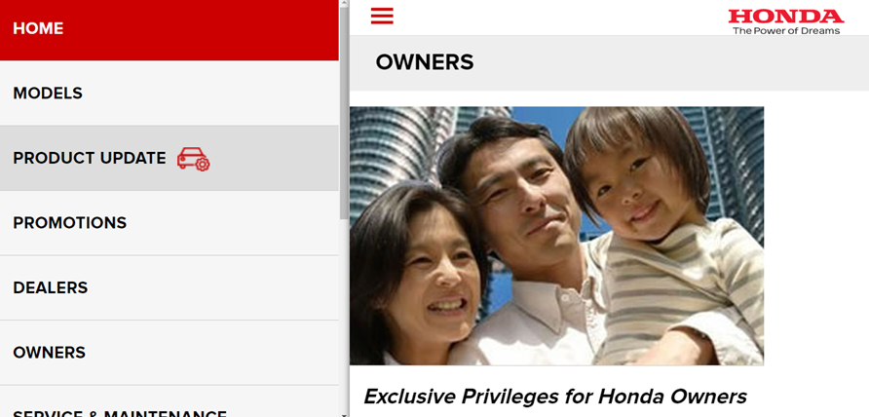

**Figure 3**: Navigation of mobile version.

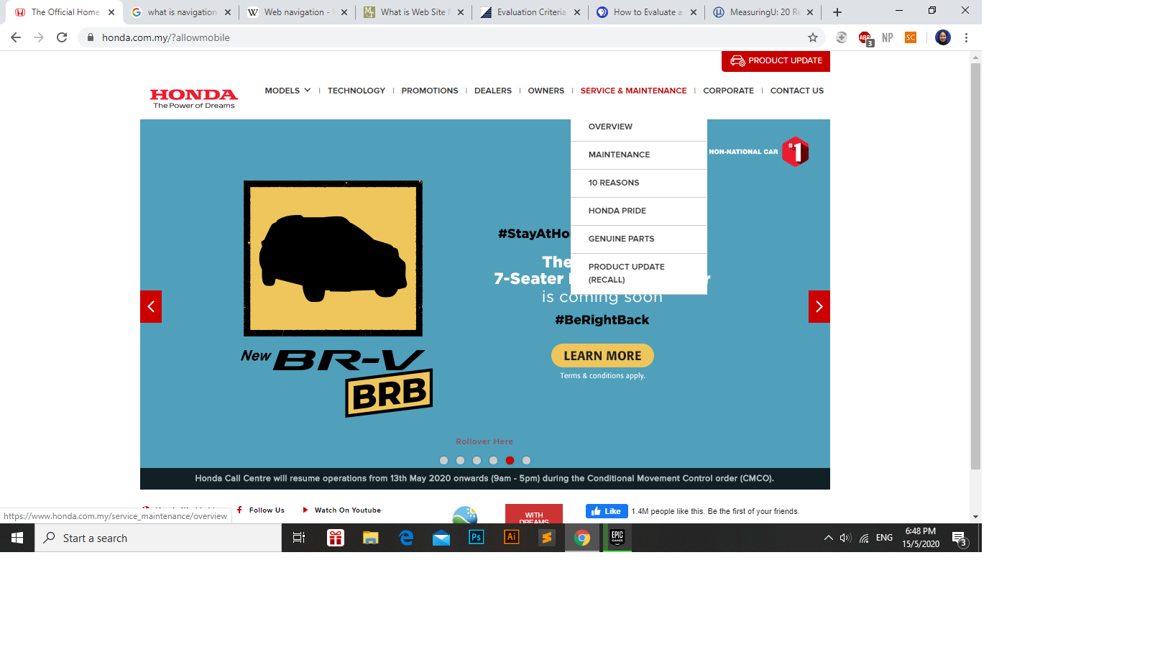

**Figure 4**: Navigation of desktop version.

**6.0 CONTENT OF THE WEBSITE**

According to ambridge Dictionary, web content can be define as the textual, aural, or visual content published on a website. Content means any creative element, for example, text, applications, images, archived e-mail messages, data, e-services, audio and video files, and so on. Honda Malaysia website has many attributes of web content in contextual aspect. Below are some of the explanation regarding the website content of Honda Malaysia Website:

* **How the Honda Malaysia use animation attributes on their website?**

Animation is one of the important factor in constructing the web content. The Honda Malaysia website developer of technician use the assistance of Flash, Ajax and other system in managing the animation attributes on their website. Animation also functioning as the enhancer in viewer point of view about website’s appearance.

* **What is the main content on Honda Malaysia website?**

The main content on Honda Malaysia website are about their car model, which is City, Civic, Jazz and many more. In addition, the content about their corporate and maintenance service that enable their customer in to booking their car service and other enquiries. Lastly, they publish about their expertise and technology as for advertising their product.

* **Why Honda Malaysia website use add content on their footer?**

Thousands of themes may be included on footer. Honda Malaysia add special and interactive content such as Facebook link to provide easy navigation to their visitor. The footer was also use to mark their copyright on any materials that publish on that website.

* **When is the time that Honda Malaysia need to update their website?**

Honda Malaysia website representative must update their website regularly, as they need to publish news, events, blog posts, seasonal promotions, special offers or other timely information on the right time. Current issue always essential on delivering the information. Thus, Honda Malaysia need to capable practising the dissemination of trending information.

* **Where mostly the content in Honda Malaysia website came from?**

All of the content in Honda Malaysia website directly generated from their own database. Despite that, the content also mostly come from Honda’s customer when they posting something on that site or updating their profile. Only authorised materials off content are allow here.

* **Who is responsible in making Honda Malaysia website newsworthy and optimize the content in everything?**

Each biggest company like Honda Malaysia must have their own board in website development whilst hire IT officer or freelance website developer to ensure the content are optimize and become user friendly towards their user. This person also responsible in to create the best content that often current and newsworthy.

**APPENDICES**

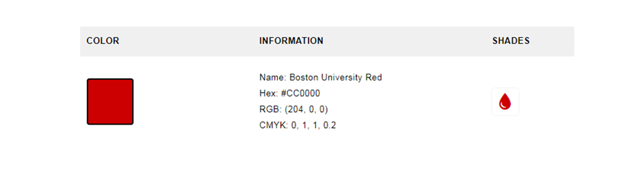

**Figure 1**: The color of Honda background.

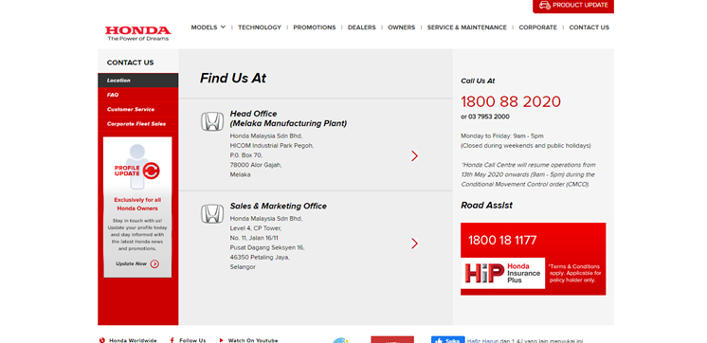

**Figure 2**: The background and section column of Honda website color.



**Figure 3**: Navigation of mobile version.

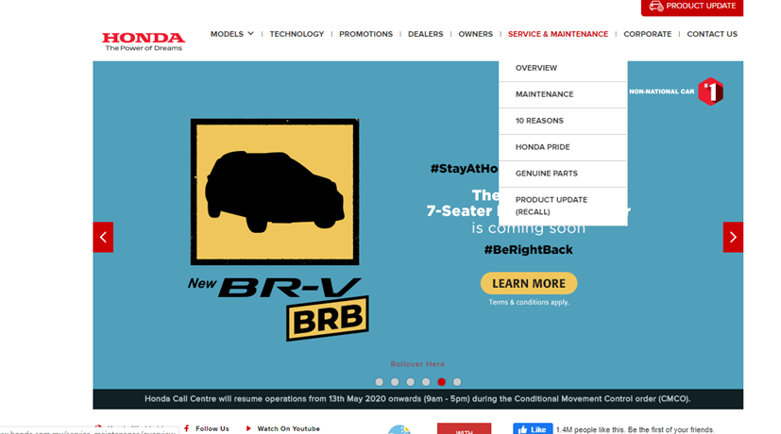

**Figure 4:** Navigation of desktop version.

**REFERENCES**

Cambridge Dictionary. (2020). *Web content*. Retrieved on May, 13 2020 at https://www.dictionary.cambridge.org/dictionary/english/web.

Honda Malaysia. (2020). *Contact us*. Retrieved on May, 12 2020 at https://www.honda.com.my/customer_service/location.

Honda Logo Color Image Format. Retrieved on May, 12 2020 at

https://www.schemecolor.com/honda-logo-colors.php